**JAVA FOUNDATION TRAINING**

**BATCH 8**

**Name:** Rajalakshmi Ganesh             **Case Study:** TicketBookingSystem

**Tasks 4: Subquery and its types**

**1. Calculate the Average Ticket Price for Events in Each Venue Using a Subquery.**

**🡪** SELECT venue_id,venue_name,

(SELECT AVG(ticket_price) FROM event e

WHERE e.venue_id=v.venue_id) AS avg_ticket_price

FROM venue v;

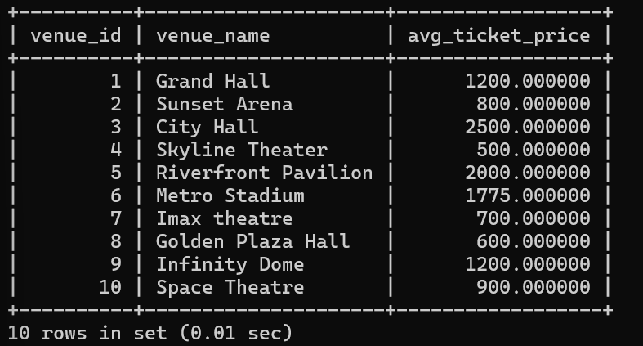

**2. Find Events with More Than 50% of Tickets Sold using subquery.**

**🡪** SELECT event_id,event_name FROM event

WHERE event_id IN(SELECT event_id FROM booking b

GROUP BY event_id  
HAVING sum(num_tickets)> (SELECT total_seats FROM

event e WHERE e.event_id = b.event_id) / 2);

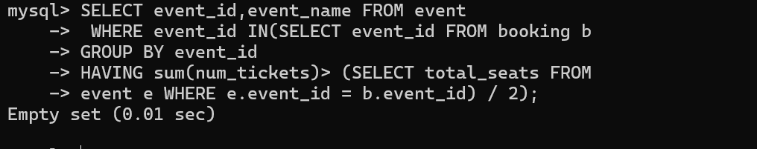

**3. Calculate the Total Number of Tickets Sold for Each Event.**

**🡪** SELECT event_id,event_name, (SELECT SUM(num_tickets) from booking b where b.event_id=e.event_id ) AS total_tickets_sold FROM event e;

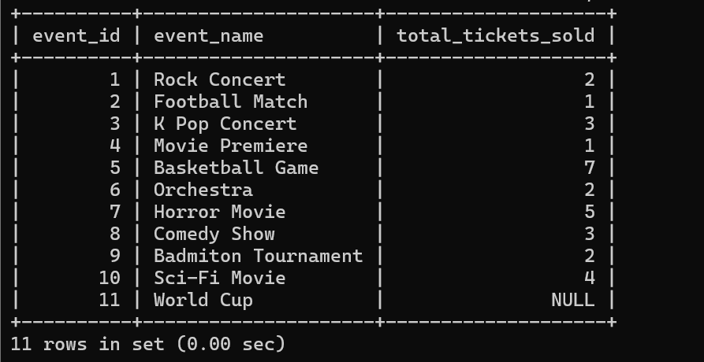

**4. Find Users Who Have Not Booked Any Tickets Using a NOT EXISTS Subquery.**

**🡪** SELECT c.customer_id,c.customer_name FROM customer c

WHERE NOT EXISTS ( SELECT 1 FROM booking b

WHERE b.customer_id=c.customer_id);

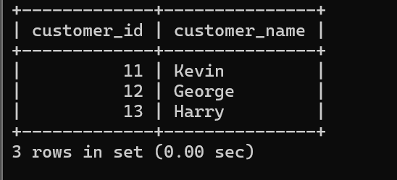

**5. List Events with No Ticket Sales Using a NOT IN Subquery.**

**🡪** SELECT event_id,event_name

FROM event

WHERE event_id NOT IN (

SELECT DISTINCT event_id from booking);

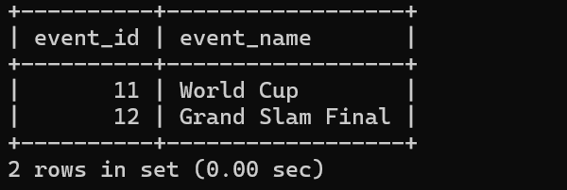

**6. Calculate the Total Number of Tickets Sold for Each Event Type Using a Subquery in the FROM Clause.**

**🡪** SELECT event_type, SUM(total_tickets_sold) AS total_sold

FROM (

SELECT e.event_type, SUM(b.num_tickets) AS total_tickets_sold

FROM booking b

JOIN event e ON b.event_id = e.event_id

GROUP BY e.event_type ) AS subquery

GROUP BY event_type;

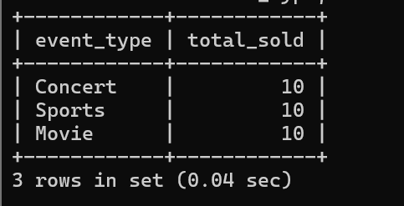

**7. Find Events with Ticket Prices Higher Than the Average Ticket Price Using a Subquery in the WHERE Clause.**

**🡪** SELECT event_id, event_name, ticket_price

FROM event

WHERE ticket_price > (SELECT AVG(ticket_price) FROM event);

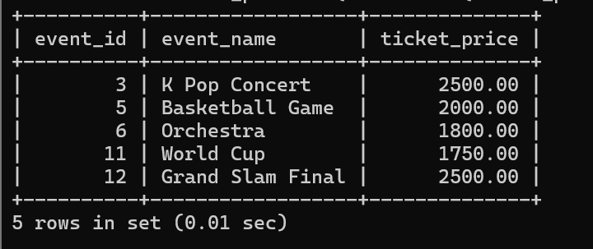

**8. Calculate the Total Revenue Generated by Events for Each User Using a Correlated Subquery.**

**🡪** SELECT c.customer_id, c.customer_name, (

SELECT SUM(b.num_tickets * e.ticket_price)

FROM booking b

JOIN event e ON b.event_id = e.event_id

WHERE b.customer_id = c.customer_id) AS total_revenue

FROM customer c;

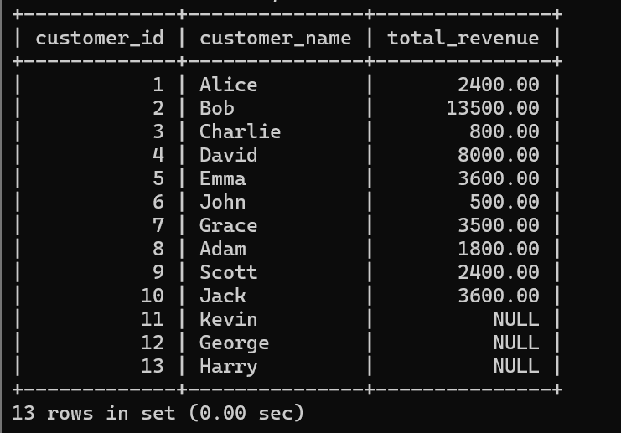

**9. List Users Who Have Booked Tickets for Events in a Given Venue Using a Subquery in the WHERE Clause.**

**🡪** SELECT customer_id, customer_name

FROM customer

WHERE customer_id IN (

SELECT DISTINCT b.customer_id

FROM booking b

WHERE b.event_id IN (

SELECT e.event_id

FROM event e

WHERE e.venue_id = 1 ) );

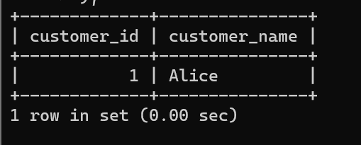

**10. Calculate the Total Number of Tickets Sold for Each Event Category Using a Subquery with GROUP BY.**

**🡪** SELECT event_type, SUM(total_tickets_sold) AS total_sold

FROM (

SELECT e.event_type, SUM(b.num_tickets) AS total_tickets_sold

FROM booking b

JOIN event e ON b.event_id = e.event_id

GROUP BY e.event_type ) AS subquery

GROUP BY event_type;

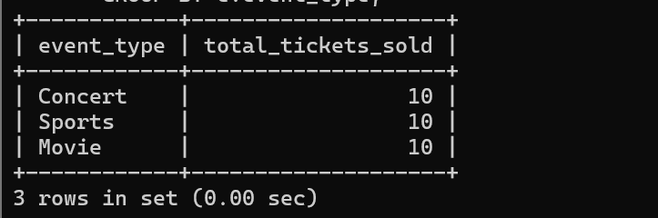

**11. Find Users Who Have Booked Tickets for Events in each Month Using a Subquery with DATE_FORMAT.**

**🡪** SELECT booking_month, customer_id, customer_name, total_bookings

FROM (

SELECT DATE_FORMAT(b.booking_date, '%Y-%m') AS booking_month, c.customer_id, c.customer_name,

COUNT(b.booking_id) AS total_bookings

FROM customer c

JOIN booking b ON c.customer_id = b.customer_id

GROUP BY booking_month, c.customer_id, c.customer_name) AS subquery

ORDER BY booking_month, customer_id;

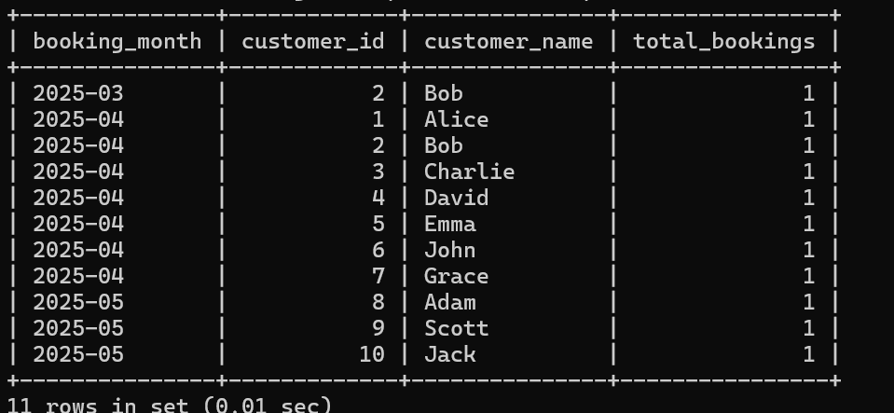

**12. Calculate the Average Ticket Price for Events in Each Venue Using a Subquery**

**🡪** SELECT venue_id,venue_name,

(SELECT AVG(ticket_price) FROM event e

WHERE e.venue_id=v.venue_id) AS avg_ticket_price

FROM venue v;

